Gregory E. Dean, MD, FACS, FAAP Lorileen Bautista, MSN, CPNP
Michael G. Packer, MD, FACS, FAAP Diana London, MSN, FNP-BC
Jonathan A. Roth, MD, FAAP Michelle Sheel, MSN, CPNP
Zarine R. Balsara, MD, PhD
Charles W. Concodora, MD

Antenatal Hydronephrosis

The anomalous development of the urinary tract can be recognized in utero, thereby prompting and permitting the evaluation of congenital uropathies prior to the onset of complications or symptomatology. The widespread use of screening maternal and fetal ultrasonography (US) has understandably revolutionized the specialty of pediatric urology.
Congenital uropathies are discovered in approximately 0.5% of screening maternal-fetal US examinations. Serial studies are indicated after discovering antenatal Hydronephrosis in order to assess progression or resolution. Furthermore, extra urinary anomalies must be sought as the incidence of compounding anomalies approaches 55%. Such a practice helps to establish perspective and facilitates counseling of the expectant parents.
The most common urologic diagnoses include: Hydronephrosis, posterior urethral valves, duplex kidneys, multicystic dysplasia, prune belly syndrome, autosomal recessive polycystic kidney disease, Potter’s syndrome, and renal agenesis. Classic and cloacal exstrophies, cloacal anomalies and imperforate anus, neuroblastoma & mesoblastic nephroma can also be detected.
Hydronephrosis is overwhelmingly the most common finding and may be physiologic and non-obstructive or it may be secondary to obstruction at the ureteropelvic or ureterovesical junctions, vesicoureteral reflux, ureteroceles, duplications or bladder outlet obstruction. It is our job to distinguish between obstructive and non-obstructive processes. The widespread use of maternal/fetal US has created an epidemic of asymptomatic infants in whom this clinical question must be answered.
Terminology
Hydronephrosis is an enlargement of the collecting system of the kidney. Hydroureteronephrosis includes the dilation of the ureter as well. The ureter is the tube that connects the kidney to the bladder. Obstruction is the restriction to urinary outflow that prevents normal renal (kidney) development or results in renal injury. The renal pelvis is a single hollow structure forming a cone-like transition from the kidney to the upper ureter area. Urine is initially collected in this area. Ureteropelvic junction (UPJ) is the site where the renal pelvis connects to the ureter. Ureterovesical junction (UVJ) is the site where the ureter connects to the bladder. A Duplication is two collecting systems from one kidney. Ureterocele is a ballon-like obstruction at the end of a ureter inside of the bladder. Vesicoureteral reflux is a condition in which the urine goes backward from the bladder up to the kidney. Posterior urethral valves are leaflets of tissue or membranous folds within the posterior urethra in males which cause bladder outlet obstruction. A multicystic kidney is a nonfunctional cystic kidney.
Testing
Ultrasonography, voiding cystourethrography (VCUG), intravenous pyelography (IVP), and diuretic renography (DR)/renal scan, are used in various combinations to evaluate the nature of the dilated upper urinary tract. Renal scans, more than any other imaging technique, have been widely promoted as the test of choice. Despite an extensive literature espousing the advantages of one imaging modality over another, insufficient data exists regarding the evaluation of upper urinary tract dilatation in infants and young children, such that a gold standard remains elusive.
A thorough background in the embryology and anatomy of the urinary tract, and a clear understanding of transitional nephrology, are necessary to formulate a strategy for diagnostic imaging and a comprehensive plan of management.
Postnatal diagnostics
& Management
Truly obstructive lesions produce renal ischemia and loss of function. Infection makes matters worse and increases the risk of permanent renal injury. Surgical correction of suspected obstruction is highly successful in infants and children of all ages. The natural history of non-operated hydronephrosis is poorly defined, however, and the validity of the diagnostic tests used for assessing these dilated upper urinary tracts remains unproven. Understandably, the management of these children is controversial.
The postnatal US is best delayed until the 3rd day of life. Earlier studies have a good chance of being falsely normal owing to a low glomerular filtration rate and relative dehydration. If Hydronephrosis is confirmed, we recommend placing the infant on amoxicillin 10mg/kg/day.
If antenatally there is suspicion for posterior urethral valves (PUV), significant (grade 3 or 4) bilateral Hydronephrosis or unilateral hydronephrosis in a solitary functioning kidney, then the postnatal US should be performed without delay and followed by the VCUG. In these cases, serum chemistries should also be checked closely, and any additional workup (DR in the case of hydronephrosis) or intervention (valve resection or vesicostomy in the case of PUV) should be expedited.
A VCUG is performed within a month of age (44 weeks post-conception) even if the postnatal US was normal because 25% of the infants with normal postnatal studies will have reflux, while more than 40% of those with persistent hydronephrosis will have reflux. If reflux is diagnosed the children are generally switched over to Bactrim after 3 months of age and are maintained on antibiotic suppression until the reflux has resolved.
In the absence of reflux, a renal scan is then performed. The renal scan should be performed in a pediatric nuclear medicine facility that adheres to the “well-tempered renogram” protocol developed by the Society for Fetal Urology and the Pediatric Nuclear Medicine Club.
Surgery for the correction of obstruction is indicated by: (1) Urologist interpretation of the renal scan (2) differential renal function less than 40%, (3) recurrent UTI, (4) increasing hydronephrosis, and (5) compensatory renal growth of the contralateral normal kidney.
If ureteral obstruction is found, (whether it lies at the UPJ, UVJ or mid ureter), surgery is required. If non-obstructive dilatation is diagnosed, or if our imaging studies are equivocal, then the US should be repeated approximately every 3 months for the first year, and a renal scan is repeated if there is a change for the worse or the clinical situation changes.
Multicystic dysplastic kidneys are followed by serial US studies. Dysplastic kidneys require removal only if their size presents problems with pulmonary or gastrointestinal function, they increase in size rather than regress over time, or if they are associated with infection. Associations between multicystic and hypertension and malignancy remain anecdotal at this time.
Duplex kidneys with or without ureteroceles are managed according to the clinical situation and the effect, if any, on all existing functioning moieties. If a neurogenic bladder or prune belly syndrome is discovered then bladder function must be assessed and efficient emptying must be assured.
Summary
Surgery for the correction of urinary tract obstruction is safe, definitive, and should be performed when obstruction is defined. Unfortunately, there is no gold standard for the evaluation of neonates and young infants. Children with antenatally detected hydronephrosis should be thoughtfully, carefully and thoroughly evaluated. Close surveillance can be practiced and continued until the hydronephrosis has resolved spontaneously or until obstruction has been proven.

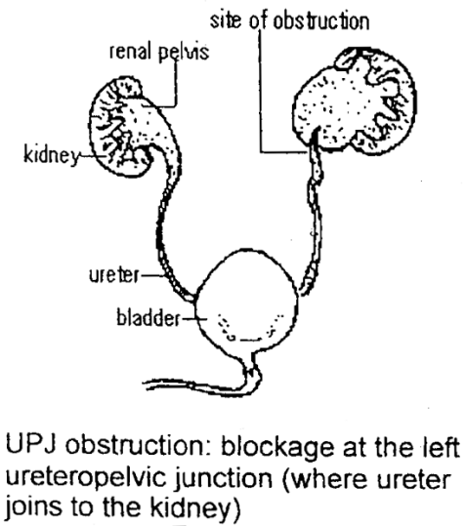

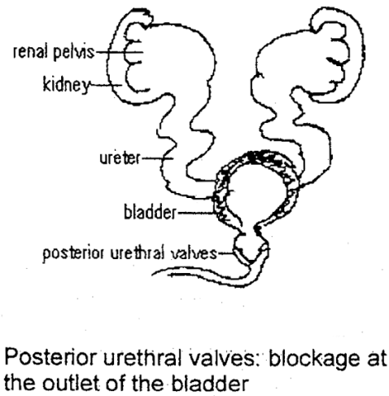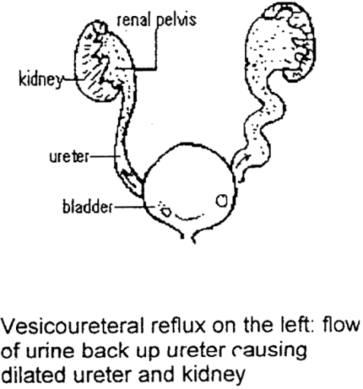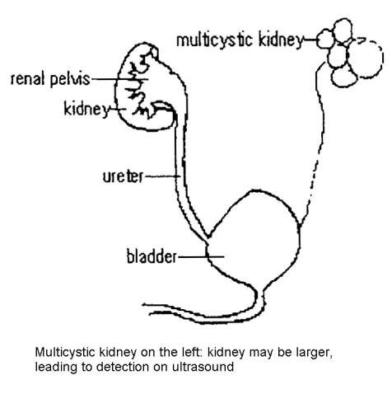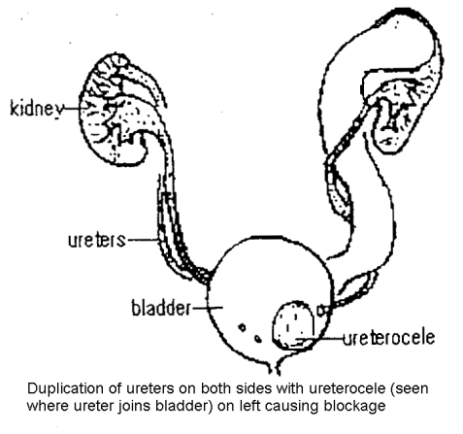

Updated September 2018

